ONLINE BOOK RESERVATION
@CREATIVITY THINK (9483175986/7019689991)

ABSTRACT:
Online Book Reservation is a web application designed to streamline the process of searching, reserving, and managing books in libraries or student centers. Users can check book availability, reserve books, and track their booking history through a dashboard. Administrators can manage the book catalog, oversee reservations, and access analytics dashboards. Built using Django, Django Rest Framework, React, Axios, and react-table, the platform ensures efficient library operations and seamless user experience..

INTRODUCTION OF THE PROJECT:
Traditional book lending and reservation systems often involve manual tracking and limited visibility for users and administrators. The Online Book Reservation system provides a centralized platform where users can search for books, reserve them, and track their history digitally. Administrators manage book inventories, approve or update reservations, and monitor usage through analytics dashboards, improving operational efficiency and user satisfaction..

PROJECT OBJECTIVES:

• Provide an online platform for book search and reservation
• Enable users to track availability and booking history
• Allow administrators to manage book catalogs and reservations
• Generate analytics for library usage and trends
• Reduce manual effort in reservation management
• Enhance user convenience with dashboards and notifications
• Ensure real-time data updates for availability and reservations
• Support academic institutions and community libraries

PROBLEM OF THE STATEMENT:
Libraries and student centers face challenges in managing book reservations, checking availability, and tracking user activity manually. Users often experience delays and limited transparency. This system addresses these issues by offering a digital platform for searching, reserving, and managing books, complemented by administrative controls and analytics dashboards..

MOTIVATION OF THE PROJECT:
• Simplify book reservation and tracking processes
• Reduce administrative workload and errors
• Provide users with real-time book availability
• Enable data-driven library management through dashboards
• Improve user engagement and satisfaction

BLOCK DAIGRAM OF PROJECT:

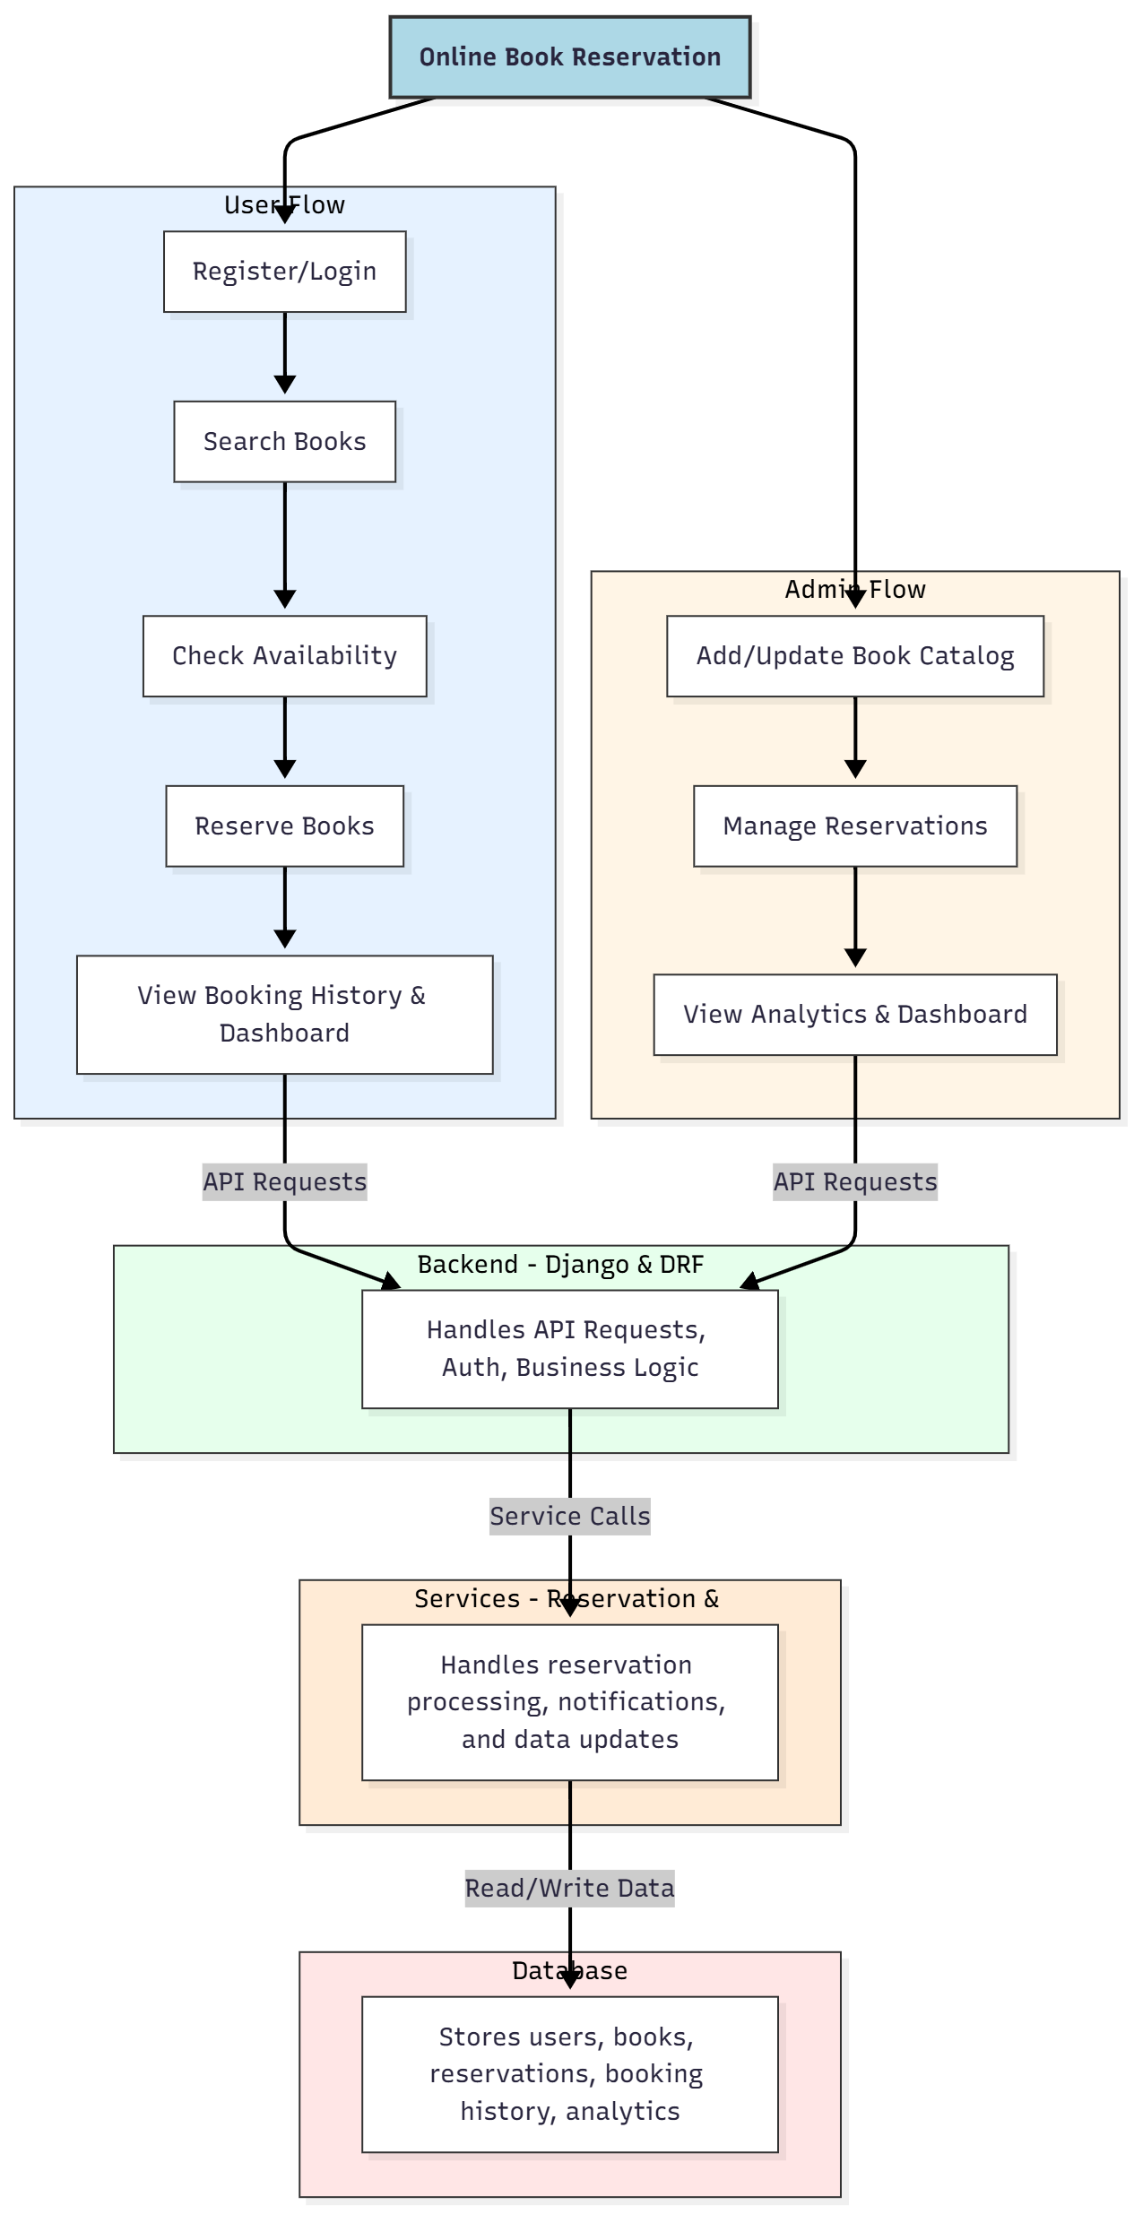

WORKING OF THE PROJECT:
Users register or log in to search for books, check availability, reserve them, and track their booking history through a dashboard. Administrators add or update book catalogs, manage reservations, and monitor platform activity via analytics dashboards. The backend handles authentication, API requests, and business logic, while services ensure real-time updates and notifications. All book, user, reservation, and analytics data are stored in a central database for efficient management..

SOFTWARE REQUIREMENT:
- Backend:
  - Python 3.x
  - Django
  - Django REST Framework
  - SQLite/PostgreSQL
- Frontend:
  - Node.js and npm
  - React.js
  - Axios
- Development Tools:
  - Visual Studio Code
  - Postman (for testing APIs)
  - Git/GitHub (for version control)
- Server/Deployment (Optional):
  - Gunicorn, Nginx, or Heroku/AWS for hosting

ADVANTAGES OF THE PROJECT:

• Centralized book search and reservation system
• Real-time availability tracking
• Dashboard for users to view booking history
• Admin control for catalog and reservations management
• Analytics dashboards for monitoring usage
• Reduces manual effort in book management
• Supports multiple libraries or centers
• Improves user convenience and operational efficiency

APPLICATIONS OF THE PROJECT:
• School and college libraries
• Public libraries
• Book rental services
• Student centers and reading rooms
• Research institutions for book tracking
• Educational resource management
• Digital library systems
• Analytics-driven library administration

REFERENCES:

- Django REST Framework Documentation — Django Software Foundation. Django Documentation. Available: https://docs.djangoproject.com/
- Django REST Framework. DRF Documentation. Available: https://www.django-rest-framework.org/
- React. React Official Documentation. Available: https://reactjs.org/docs/getting-started.html
- Redux. Redux Documentation. Available: https://redux.js.org/introduction/getting-started
- PostgreSQL Global Development Group. PostgreSQL Documentation. Available: https://www.postgresql.org/docs/
- MySQL. MySQL Reference Manual. Available: https://dev.mysql.com/doc/
- Git. Git Documentation. Available: https://git-scm.com/doc
- Node.js. Node.js Documentation. Available: https://nodejs.org/en/docs/
- Axios. Axios Documentation. Available: https://axios-http.com/docs/intro
- Socket.io Documentation – https://socket.io/docs/

